**Download and Install Git**

1. **Download Git for Windows (** [**https://git-scm.com/**](https://git-scm.com/) **).** After downloading, run the installer.

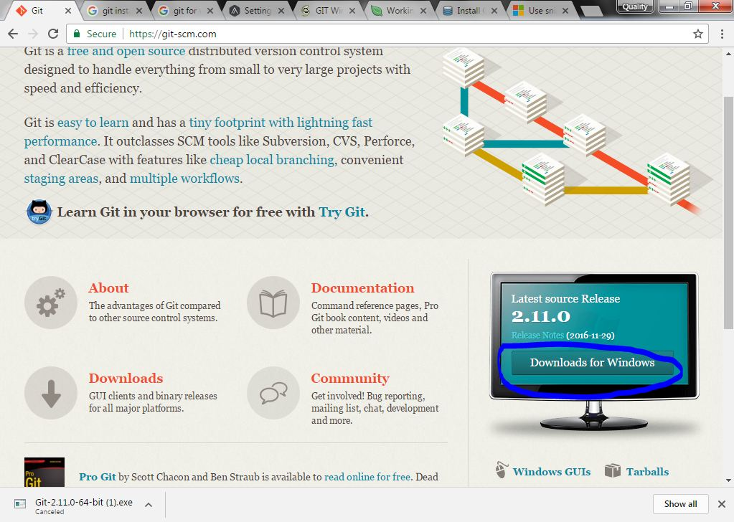

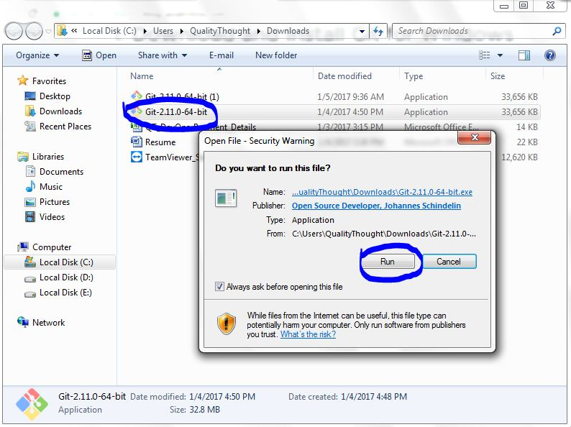

1. Simply Click on next .. button.
2. From here, the process become quite streamlined. Simply follow the setup steps to ensure optimal settings. We recommend selecting "Use Git Bash only" as it provides an unmodified PATH.

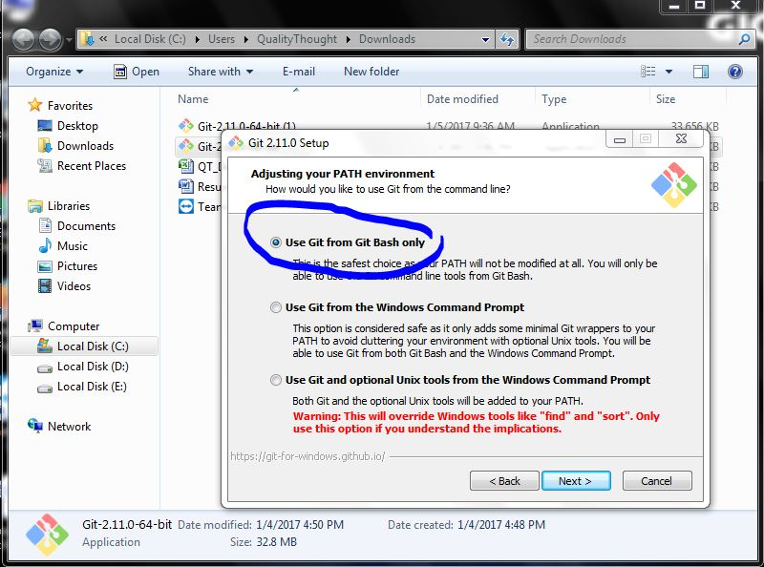

1. After selecting next, we recommend chosing the option of "Checkout Windows-style, commit Unix-style line endings". Click next button.

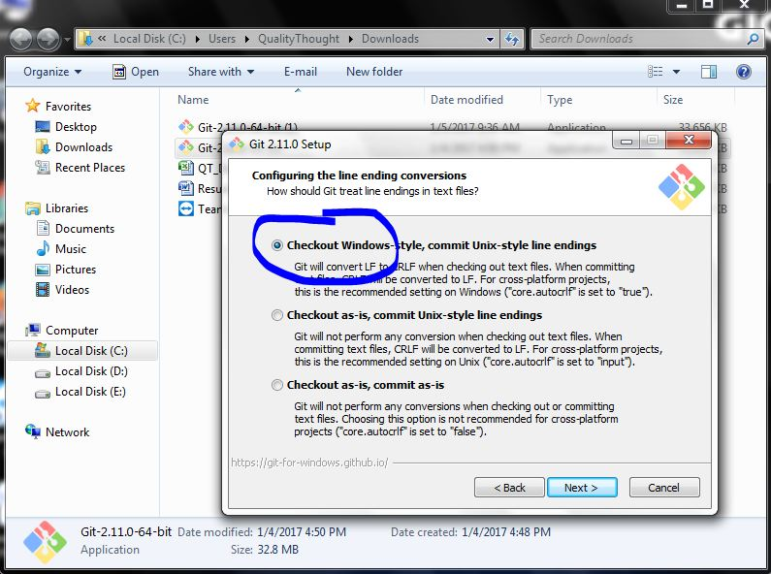

1. After selecting next, we recommend chosing the option of "use Min TTY ". Click next button

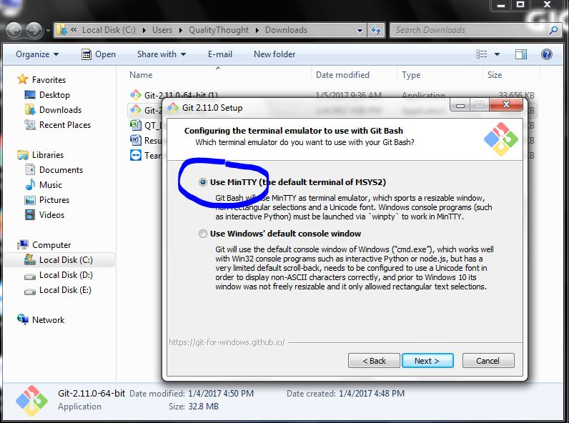

1. After selecting next, we recommend chosing the option of "enableing file system caching ". Click next button

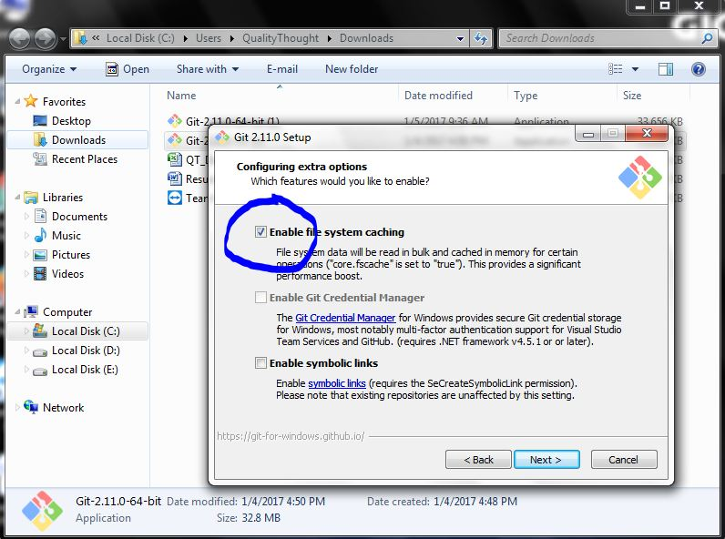

1. Once you click on next button you will see installation window. Select install once you have done this.

